**ASIC Implementation of Motion Estimator in 32/28nm CMOS**

**ENGR 852**

**Andrew Miller**

**Ali Attaran**

Table of Contents

Project concept and abstract 3

1 Introduction 4

2 Problem Statement 4

3 Power specification 5

4 The Proposed Architecture 5

4.1 Full-Search Block Matching Algorithm 5

4.2 Validation 12

5 Synthesis 13

6 Static Timing Analysis 14

7 IC Compiler 14

8 Architecture’s Performance 17

Conclusions 17

References 17

Table of Figures

Figure 1. PE schematic 8

Figure 2. PE waves 8

Figure 3. Comparator Module schematic 10

Figure 4. Comparator waves 10

Figure 5. Control waves 11

Figure 6. (a) 16x16 size Rmem (b)31x31 size Smem 12

Figure 9. Mapping of the gates 15

Figure 10. Floor planning, placing, highlighted clock wires and routing 16

Table of Tables

Table 1. Performance parameters 13

Table 2. Parameter Comparison 13

# Project concept and abstract

Motion estimation is one of the key components of high compression video codecs.

The most popular algorithm for motion estimation is block matching algorithm due to simple hardware implementation. The goal in this project is to design the motion estimator from HDL to GDS in the 32/28nm CMOS technology.

**Design Specifications (Constraints and Goals):**

The design is expected to meet the speed of15 frames per second. The picture is gray-scale coded (8 bits per block). The reference block is 16x16 pixels and the search window is 31x31 pixels. There are 4096 reference blocks in a frame.

The design goal is to minimize the total area and energy consumed by the logic over the entire simulation of the test set. The design must operate at the speed given above.

**Verification Plan:**

Several test benches will be developed with known motion vectors to test the functionality of the all the modules and the top module. These test benches will be applied to the design and the results will be compared against expected outcomes. The expected outcomes will be produced using a reference model or manually and compared against the outcomes produced by the design under test.

# Introduction

Motion estimation is an inter-coding technique, which refers to finding the correlation between two adjacent video frames which we call the current frame (called ‘Smem’ in HDL) and reference frame (called ‘Rmem’ in HDL). This technique exploits the possible temporal redundancy (similar pixel values from frame to frame that may be a simple vector translation apart) present in the video frame. However motion estimation is one of the most computationally intensive parts of many video encoders and it is highly desirable to make motion estimators faster and more efficient. A single memory block size (a piece of the larger picture frame) is 16x16 8-bit pixels, and the sum of absolute difference (SAD) is calculated between the reference and current block, the least of which is stored to estimate the best-guess motion. What actually gets stored and reported to the system after a calculation is the motion vector, which is simply the translation vector that would be applied to each pixel to apply the perceived motion between two frames. It is assumed that a higher level controller will make use of the motion vector, and that the only job for a motion estimator is to provide the most likely motion vector given two frames [1]. In this project, 3.84ns clock period is chosen and with clock period of 3.84ns, positive slack time of 0.07ns and 1.92ns in hold and setup timing reports in the final post layout generation stage in critical path is achieved. The hold and setup time after post layout simulation and extracting the parasitic parameters are 0.07ns and 1.92ns, respectively.

# Problem Statement

The objective of motion estimation is to find the displacement of a given piece of a picture frame, or block, in the current frame compared to its initial position in the reference or previous frame, assuming the picture is not new but simply moved a small amount. To reduce the cost of searching, the search is restricted in a given search window [2]. A cost function, the sum of absolute difference (SAD), is used to find the best possible match for a given current block from a reference frame to the current frame.

 (1)

The value is recorded by specifying the displacement, motion vectors referred to vectorX and vectorY in HDL code. In this process of computing, the motion vectors may be calculated for each search block in the current frame either in parallel or sequentially based on final design requirements. In this project we design one such motion estimator which may be used to calculate the motion vector within one clock period time duration.

# Power specification

A major problem is the lack of available reference power figures from the ME block of commercial encoders. It is relatively easier to find out the power consumption of the whole encoder chip, but it is very difficult to find out how much power is consumed by the motion estimation inside the encoders. So the power consumption of the all the modules are reported.

# The Proposed Architecture

## Full-Search Block Matching Algorithm

FBMA is one of the motion estimation techniques that compare one block of the current frame with all of the blocks of the next frame to decide where the matching block is located. Considering the number of computations that has to be done for each motion vector within the constraints for this project, we need a device that can work fully in parallel to reduce the required processing time. In our design, each frame of the video is partitioned into search windows of size 16x16 8-bit pixels (picture elements). Our Motion Estimator then breaks the given piece into smaller blocks of size 8x8 pixels. Each pixel holds an 8-bit number, which resembles one of the 256 color codes that the pixel should generate [3]. To calculate the motion vectors, a series of calculations must be done. First, the current and next frames are divided into blocks of 8x8 bytes (pixels). Each block of the current frame must be compared to all of the blocks of the next frame to find the matching block. To compare the blocks, we have to subtract each of the pixels of the current frame, from the pixels of the next frame. So, for each block of size 8x8, there are 64 subtractions to be done [4].

All of the differences of the block should be added to obtain the sum of absolute difference (SAD) related to each block. The block with the minimum value of the SAD is our desired block. The location of that block is the motion displacement vector for that blocks in current frame, which is simple the vector difference between the current position and the block’s position. If we let the motion displacement vector between the present block and the NxN region in the reference frame be represented by (m,n), and number of rows and columns of the block by i and j , SAD can be calculated using Equation (2) [5].

 (2)

In the above equation, N will be 8, since the size of the block is 8x8. The search window is of size 16x16 pixels; therefore, we will have 15x15 = 225 blocks of size 8x8 pixels. Each of these blocks will have a motion displacement vector relating to them. Consequently, we will have 225 motion vectors for each search window of a frame instead of all the data required to update the frame. A queue of size 30 bytes will be used frequently during the process. The first 22 bytes store the first row of the search window, and the remaining 8 bytes store the first row of the original block. 16 Processing Elements (PE) are used to process the SAD of each row in parallel [6] [7].

The architecture of the motion estimator design from the lecture note is taken for this project. It uses two sets of local memory for each search window of size 16x16 pixels. For the purpose of this report, the process details are limited to one search window of the frame. Additional architectures can work in parallel for frames of greater size.

We have to search all possible combinations of blocks, because we are trying to find the matching block in the next frame. There are 16 columns of different blocks of size 8*8 in a window of width 22 bytes. These blocks are processed in processing element (PE) modules as shown in fig. 1.

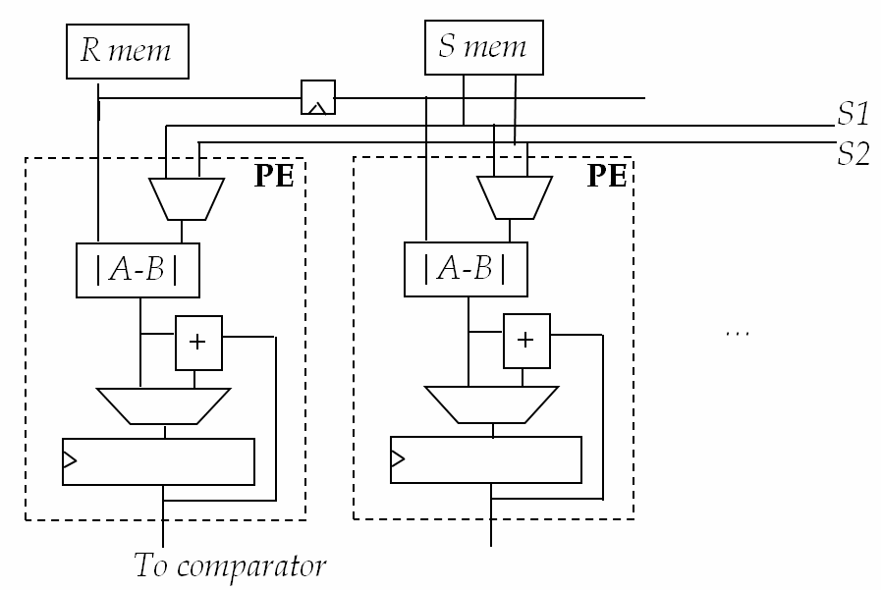

Figure 1. PE schematic

There are 16 PE modules in the top motion estimator module. The PE module compares the frame or pixel difference between the Smem and Rmem and if the difference is more than new distortion value, it will accumulate the new difference into new distortion value. These 16 PEs are pipelined for faster processing. The testbench simulation for PE module is shown in Fig. 2

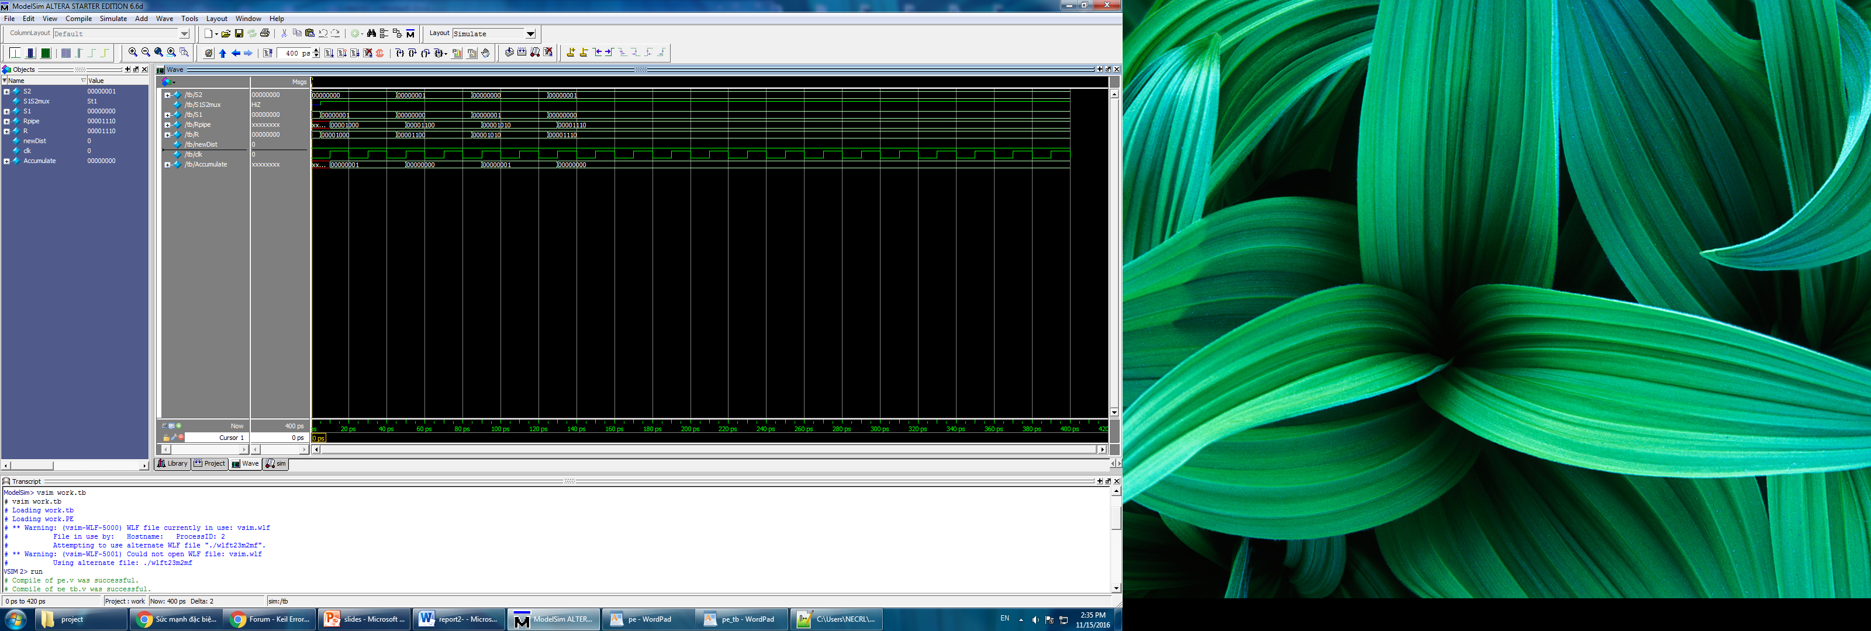

Figure 2. PE waves

In each PE (fig. 1), 8 bytes of the frame are connected to a multiplexor and the output to a subtractor (A-B). The other input of the subtractor comes from another multiplexor that has 8 inputs form the original block frame. Therefore, in each clock cycle, 15 bytes of the frame are subtracted from the one in the original block. For example, if we name the frame bytes from 21 -0, bytes 7-0 go to first multiplexor, bytes 1- 8 go to second one, and etc. Thus, in the first cycle, byte 0 from first multiplexor gets subtracted from byte 0 of the original multiplexor. Simultaneously, byte 0 of the second multiplexor (byte 1 of the frame) gets subtracted from the same byte 0 of the original frame, and the same happens for all 16 PES. The total amount of subtractions needed for one block is 64, and each subtraction takes one clock cycle, so after 64 clock cycles we will have all the differences calculated. After each subtraction, the result is stored in a register called “sum reg.” In the next clock cycle, next pixels are subtracted from each other while the result is added to the “sum reg.” After 8 clock cycles, all 16 PES have done the subtractions, and as a result, the SAD of the row is calculated. Also, the queue is updated with a new line of 22 bytes. If we go through this process 8 times, we have covered 8 lines of data, which means that we have the SAD of all 15 blocks of that row.

Now, we need to compare them to find the smallest value. This is done is comparator module (fig. 3). Each PE is selected by the multiplexer and comparator puts its output value in the new distortion and after comparing them, it chooses the minimum value between them. The motionX and motionY vectors are the best motion vectors so far to estimate the Rmem and Smem frame difference. The testbench simulation for comparator module is shown in figure 4.



Figure 3. Comparator Module schematic

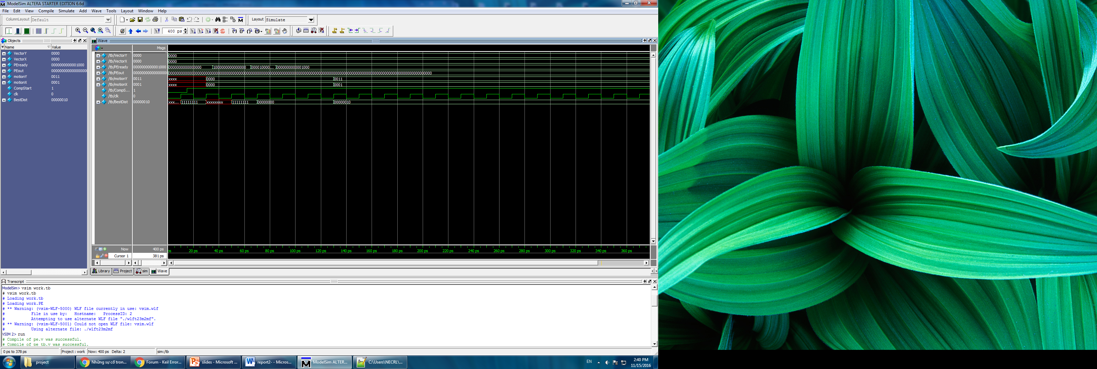

Figure 4. Comparator waves

The smallest value is related to a location in the frame that is our motion vectors. This part that is called the addition will happen in parallel to the subtraction with one clock cycle delay. Therefore, if we add all the delays for subtraction and addition, we get the total number of 65 clock cycles needed to calculate the SAD of each row of 15 blocks. The comparison, as the second level, will start the after the SAD is computed. As mentioned above, the SAD of the block will take 65 clock cycles to be calculated, so the second level will start the comparison every 65 clock cycles in parallel to first level operations. To compute the motion vectors, vectorX and vecotY will indicate the y-coordinate and x-coordinate of the block. These coordinates will be stored in “MotionY” and “MotionX” respectively. They will get updated only if the result of the comparison between SAD and the new SAD is positive and we want to update the SAD with the smaller value. Finally in control module, all the control signals such as PEready, vectorX, vectorY, NewDist, S1S2mux, address to Rmem, Smem are generated (fig. 5).

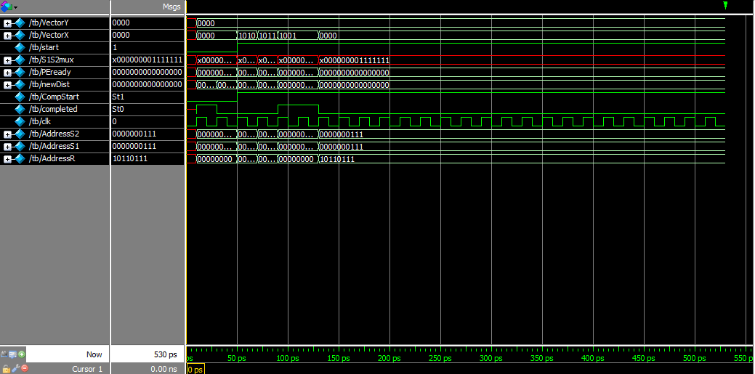

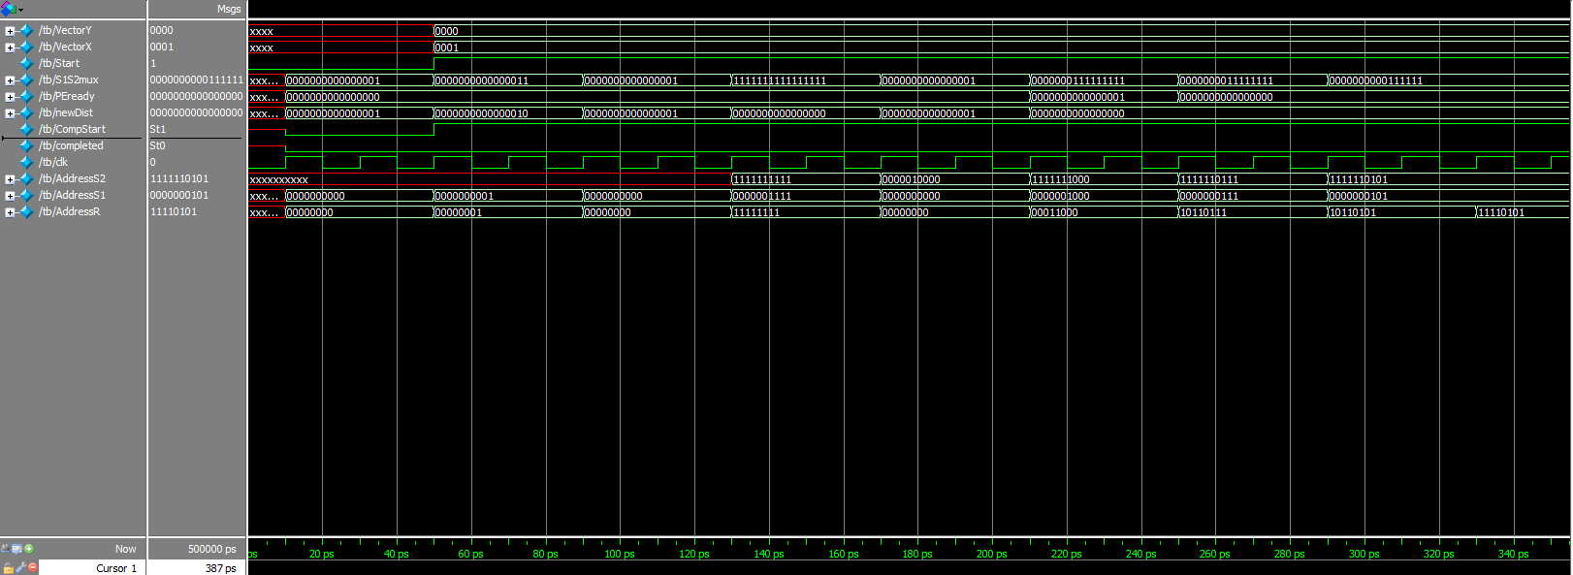

Figure 5. Control waves

After all the data of the frame is processed, we will have the final motion vector relating to the minimum SAD. Also, it is noticeable that the “row counter” and “column select” will start from 0-14, because we cannot have block sizes of less than 8x8.

## Validation

All these modules need to be simulated in the top motion estimator module. The external Rmem and Smem are generated manually in excel files in order to compare the simulation results with the expected results. A dark image is put in the Rmen starting from position (7,6) (as in Fig. 6(a)) and we moved the same size image 2 and 1 vectors right and up, so the expected motion X and Y should be 2 and 1, respectively as illustrated in fig. 6 (b).

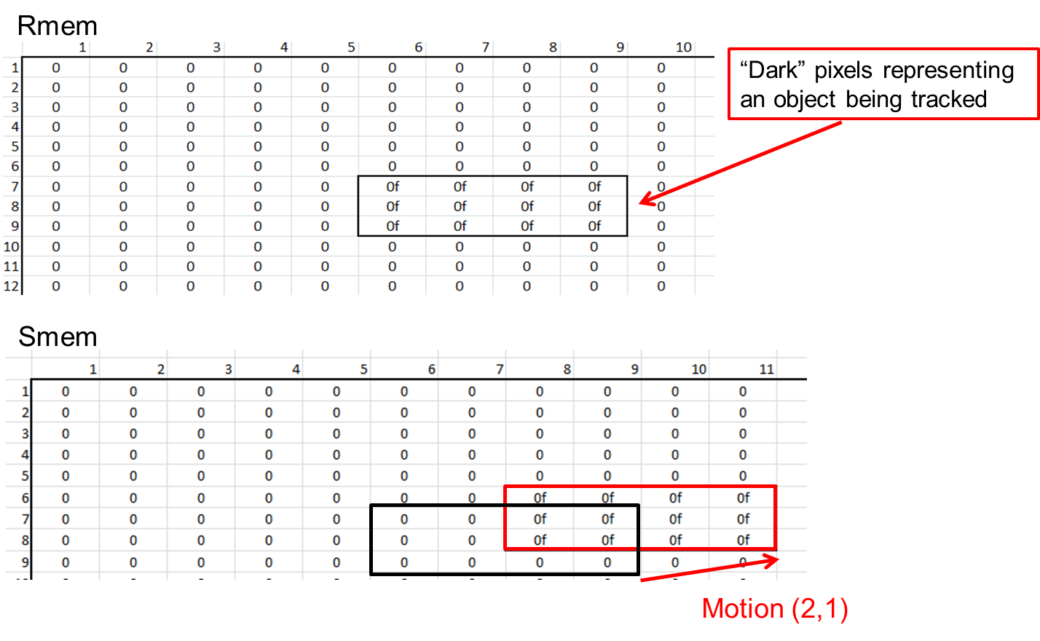

Figure 6. (a) 16x16 size Rmem (b)31x31 size Smem

The testbench simulation of the top module code is shown in fig. 6 and the design performance parameters are shown in table1. We also compared our design with the similar motion estimator designs in literature shown in table 2.

Table 1. Performance parameters

|  |  |  |  |  |
| --- | --- | --- | --- | --- |
| **Period (nS)** | **Slack time (nS)** | | **Power (uW)** | **Area** |
| **3.84** | **0.07** | **1.92** | **277.4** | **7775.4** |

Table 2. Parameter Comparison

|  |  |  |  |
| --- | --- | --- | --- |
| **Parameter** | **[8]** | **[3]** | **This work** |
| # of PE | 16*16 | 16*16 | 16*16 |
| Process | 0.18 um | 0.35 um | 32nm |
| Gate count | 154 K | 106 K | 1.5 K |
| On Chip Memory | 60K Bits | 24 K Bits | 2K Bits |
| Frequency | 100 MHz | 66 MHz | 260 MHz |

# Synthesis

After verifying the functionality of the all the sub-modules and the top module, we proceed to synthesis and RTL conversion. Synthesizing a design is an iterative process and begins with defining timing constraints for each block of the design. These timing constraints define the relationship of each signal with respect to the clock input for a particular block. In addition to the constraints, a file defining the synthesis environment is also needed. The environment file specifies the technology cell libraries and other relevant information that DC uses during synthesis. In the synthesis script, clock and area constraints are defined and related reports such as timing, area and power are generated. The synthesized gate-level netlist code is generated from the modules as well.

# Static Timing Analysis

Next, in pre-layout timing analysis, synthesized database along with timing information from the synthesis process used to perform a Static Timing Analysis.

Although, the chip-level static timing can be performed using the above approach, PrimeTime is a preferred tool for timing analysis. PrimeTime is the Synopsys stand-alone sign-off quality static timing analysis tool that is capable of performing extremely fast static timing analysis on full chip-level designs. It provides a Tcl interface that provides a powerful environment for analysis and debugging of designs.

# IC Compiler

In IC Compiler environment, floor planning, placing, routing, clock tree synthesis and extracting parasitic parameters are performed. Mapping of the gates in the netlist can be assigned with different colors as shown in fig. 8. The quality of floor plan and placement is more critical than the actual routing, as shown in fig. 9. Optimal cell placement location, not only speeds up the final routing, but also produces superior results in terms of timing and reduced congestion. The constraint file is used to perform timing driven placement. The timing driven placement method forces the layout tool to place the cells according to the criticality of the timing between the cells.

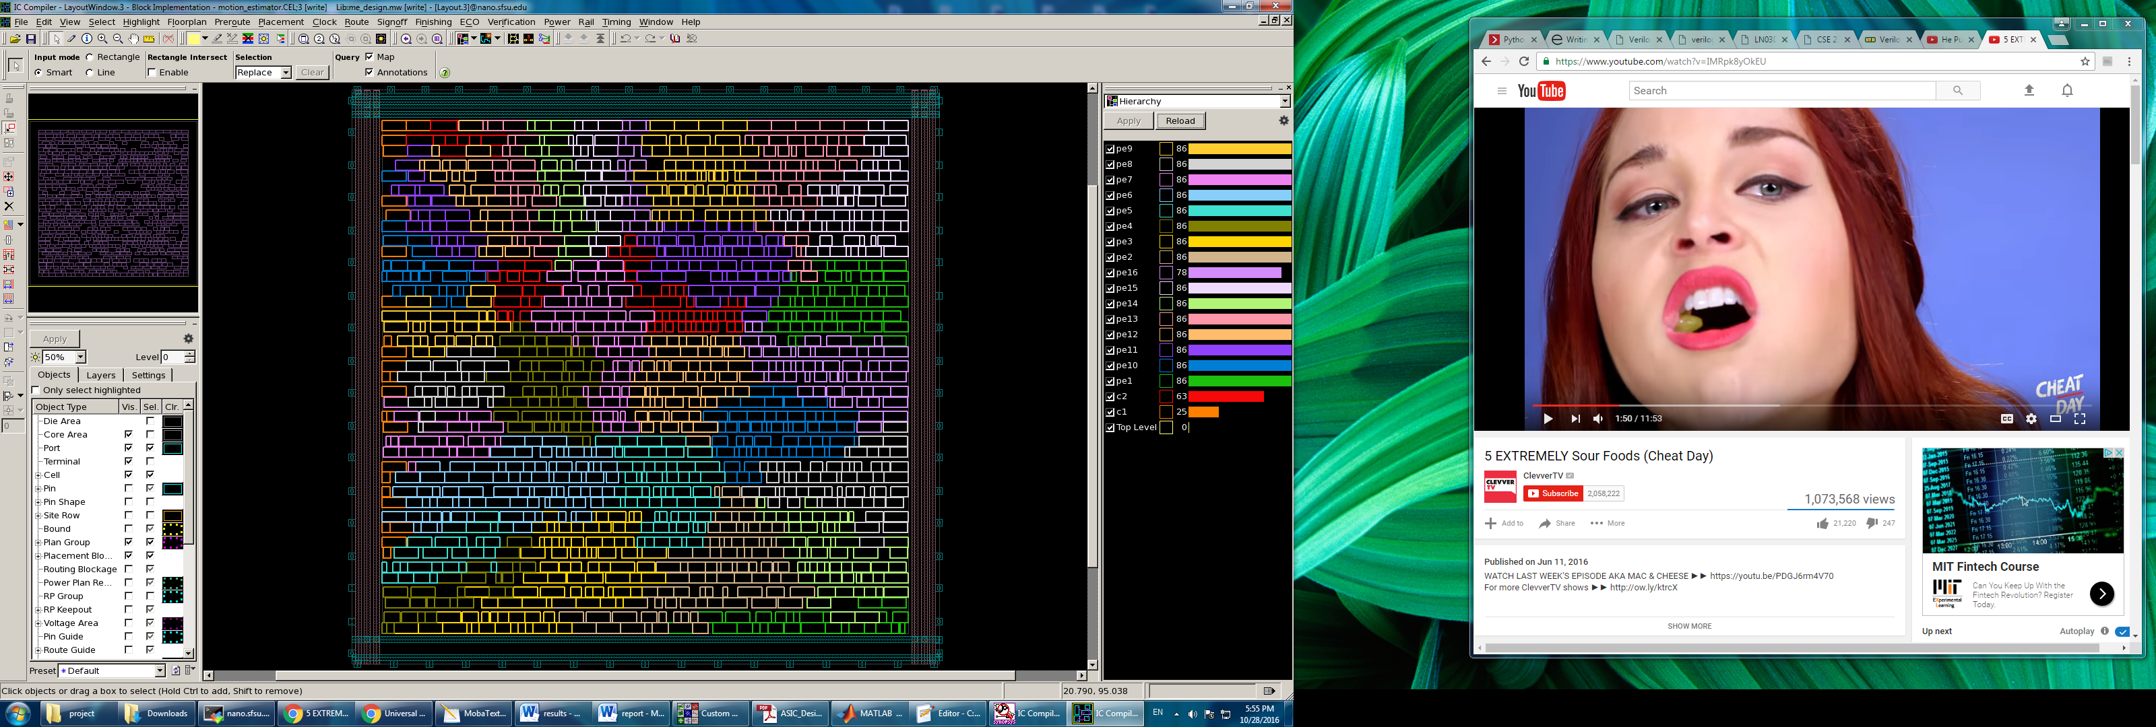

Figure 9. Mapping of the gates

The layout tool generally performs routing in two phases – global routing and detailed routing. After placement, the design is globally routed to determine the quality of placement, and to provide estimated delays approximating the real delay values of the post-routed (after detailed routing) design. If the cell placement is not optimal, the global routing will take a longer time to complete, as compared to placing the cells. Bad placement also affects the overall timing of the design. Therefore, to minimize the number of synthesis-layout iterations and improve placement quality, the timing information is extracted from the layout, after the global routing phase. Although, these delay numbers are not as accurate as the numbers extracted after detailed routing, they do provide a fair idea of the post-routed timing. The estimated delays are back annotated to PrimeTime for analysis, and only when the timing is considered satisfactory, the remaining process is allowed to proceed. Detailed routing is the final step that is performed by the layout tool. After detailed route is complete, the real timing delays of the chip are extracted, and plugged into PrimeTime for analysis. These steps are iterative and depend on the timing margins of the design. If the design fails timing requirements, post-layout optimization is performed on the design before undergoing another iteration of layout. If the design passes static timing analysis, it is ready to undergo LVS (layout versus schematic) and DRC (design rule checking) before tape-out.

C:\Users\NECRL\Desktop\ali\asic\project\Picture1.tif

Figure 10. Floor planning, placing, highlighted clock wires and routing

Next in the post-layout mode, the actual extracted delays are back annotated to PrimeTime to provide realistic delay calculation. These delays consist of the net capacitances and interconnect RC delays. Similar to synthesis, static timing analysis is also an iterative process. It is closely linked with the placement and routing of the chip. This operation is usually performed a number of times until the timing requirements are satisfied. After meeting timing constraints in post-layout stage in PrimeTime, the final reports are generated and we can record our design performance parameters.

# Architecture’s Performance

Conclusions

For measuring the performance of the design, the clock frequency is 3.84ns (260MHz) to meet the design spec. This project presents an architecture that uses full-search block matching algorithm to estimate the movement of blocks in a frame as oppose to updating the entire frame. The major characteristic of this design is its parallel performance. That leads to less power consumption with higher throughput. The chip area is 7775.4. The total power is 277.4uW. This design is best suitable for small mobile devices that need Internet access or any kind of video streaming. In this project, 3.84ns clock period is chosen and with clock period of 3.84ns, positive slack time of 0.07ns and 1.92ns in hold and setup timing reports in the final post layout generation stage is achieved.

References

[1] J. S. Cardoso and L. Corte-Real, "Accumulator size minimization for a fast cumulant-based motion estimator," *IEEE Transactions on Circuits and Systems for Video Technology,* vol. 15, pp. 1660-1664, 2005.

[2] Z. Huanqiang, C. Canhui, and M. Kai-Kuang, "Fast Mode Decision for H.264/AVC Based on Macroblock Motion Activity," *IEEE Transactions on Circuits and Systems for Video Technology,* vol. 19, pp. 491-499, 2009.

[3] M. G. Koziri, A. N. Dadaliaris, G. I. Stamoulis, and I. X. Katsavounidis, "A Novel Low-Power Motion Estimation Design for H.264," in *2007 IEEE International Conf. on Application-specific Systems, Architectures and Processors (ASAP)*, 2007, pp. 247-252.

[4] S. Jun-Fu, W. Tu-Chih, and C. Liang-Gee, "A novel low-power full-search block-matching motion-estimation design for H.263+," *IEEE Transactions on Circuits and Systems for Video Technology,* vol. 11, pp. 890-897, 2001.

[5] K. Minho, H. Ingu, and C. Soo-Ik, "A fast VLSI architecture for full-search variable block size motion estimation in MPEG-4 AVC/H.264," in *Proceedings of the ASP-DAC 2005. Asia and South Pacific Design Automation Conference, 2005.*, 2005, pp. 631-634 Vol. 1.

[6] W. D. Harris and J. H. Lang, "A simple motion estimator for variable-reluctance motors," *IEEE Transactions on Industry Applications,* vol. 26, pp. 237-243, 1990.

[7] W. Chen-Mie and Y. Ding-Kuen, "A VLSI motion estimator for video image compression," *IEEE Transactions on Consumer Electronics,* vol. 39, pp. 837-846, 1993.

[8] Y. K. Ko, H. G. Kim, H. C. Oh, and S. J. Ko, "Fast VLSI motion estimator based on bit plane matching," *Electronics Letters,* vol. 36, pp. 1923-1924, 2000.